FARNDON ANNUAL PARISH MEETING
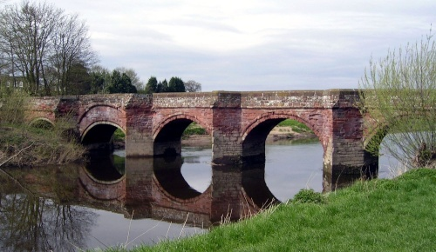

TUESDAY 3rd APRIL 2018, 7pm,
AT FARNDON WAR MEMORIAL HALL.
ALL WELCOME
***********************
PROGRAMME:
- CHAIRMAN’S REPORT
- OPEN FORUM
*********************

For further information contact the clerk:
Claire Taylor 01829 270887 / farndonparishclerk@gmail.com

